**Netflix Data Analysis Documentation**

**Introduction**

Netflix is a streaming service that offers a wide variety of award wining TV shows, movies, animation, documentaries and more on thousands of internets connected devices.

**Data pre-processing**

Python libraries such as pandas, seaborn, Numpy and Matplotlip were used for the analysis. I use this tool for cleaning and statistical analysis.

The cleaning process involves checking the dataset for

* Null values

Null values are most of the time not useful for analysis because they can impact the accuracy and integrity of the data

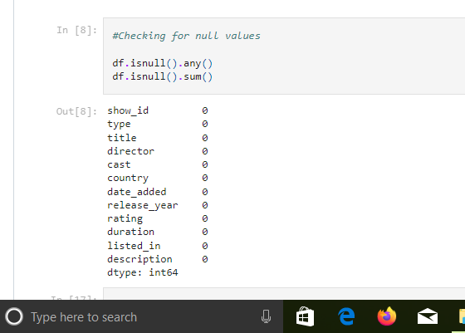

* Checking for the number of unique values

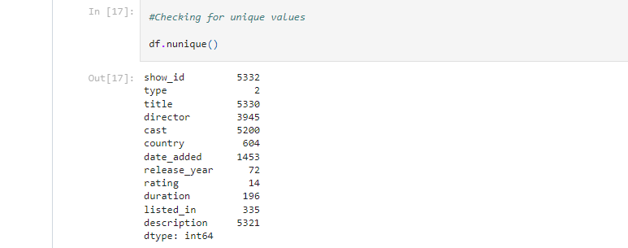

* Removing Duplicates; In every pre-processing, it is important for duplicate to be removed to avoid inaccurate analysis or insights

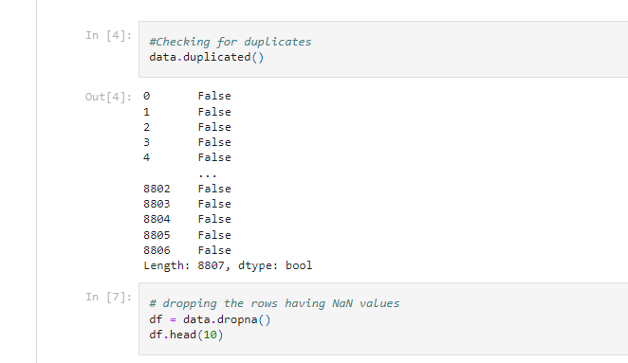

so much more.

**Grass root problem**

This analysis is done to answer few questions using power BI and suggest possible reasons and solutions to the problem.

1; what is the total number of titles uploaded on Netflix



According to the chart above, over 8,800 titles, including movies and TV shows were uploaded.

2; What is the distribution of movies and TV shows in the dataset

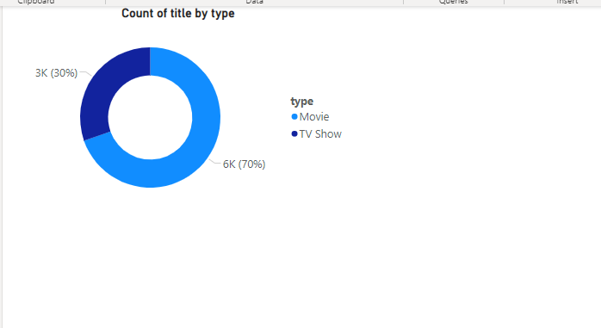

From the chat, the most distributed type is the movie category because it has high percentage of titles. Reasons why include and not limited to

* Netflix is a streaming platform that tend to meet the most needed type by its audience and as such, high percentage of the public like to stream movies than TV shows. This could be one of the reasons for uploading more of movies than TV shows
* Also, Netflix might have more movie license than that of the TV shows and this can be because movies are mostly created by small companies and networks thereby making the license accessibility easier.

3; which country have the highest number of movies and TV shows produced.

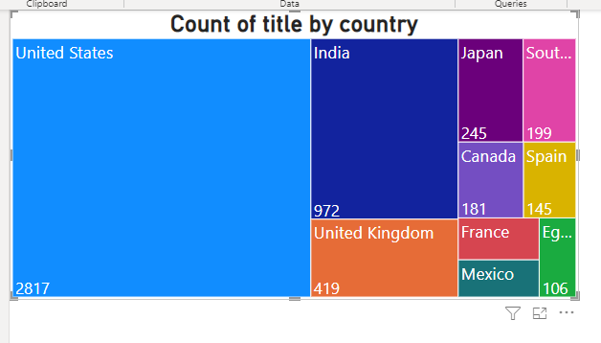

From the tree map above, United states have the highest number of movies and TV shows produced with the total of 2817 titles. To increase the availability of movies and TV shows from other countries;

* Netflix could partner in film festivals by supporting film productions and events and in return Netflix gets more international movies from these countries
* Netflix can conduct market research to understand the preferences of local audiences in these countries and tailor their content offerings accordingly
* Netflix could provide incentives to film makers and producers to enable them provide more content for the platform.

4; How has the number of movies and TV shows added to Netflix changed over time and why?

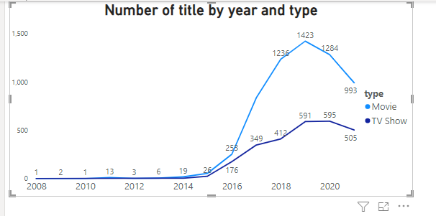

From the chat above, we can see that there is increase the number of movies and TV shows added by Netflix over the years. Also, the chat shows that Netflix has it highest number of titles in the year 2019. In the year 2021 there is a decline to the number of movies and TV shows added. These could be because,

* Decrease in the number of movies and TV shows produced during the pandemic
* Also, with the rise of other streaming apps such as showmax, prime video e.t.c. Netflix will be feeling pressured to compete in a wider content. There by allocating resources on other content other than movies and TV shows
* Netflix might not be able to access license to more movies and TV shows at the time due to cost constraint.
* There could also be a change in user preferences.

5; What is the average duration of movies and TV shows on Netflix (Taking number of episodes to be 5 and duration to be 45mins for each episodes)

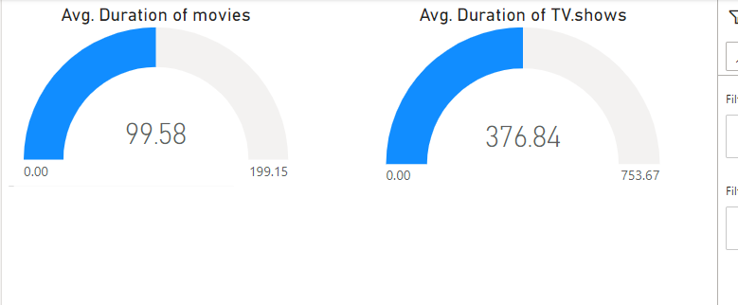

Base on the gauge chart above, it appears that average duration of TV shows is higher compared to movies. This is because most TV shows are structured in episodic narratives, with each episode lasting for about 45minutes. In this case, a single season have 5 episodes. In contrast, movies typically have a single narrative that lasts for 90 to 180 minutes, with no breaks or episodes. Therefore, the difference in duration between movies and TV shows is largely due to their different storytelling formats.

6; What are the top 10 directors of movies and TV shows on Netflix

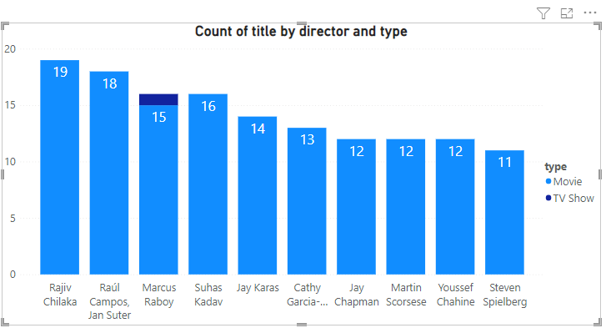

Rajiv chilaka is the director with the highest number of movies uploaded by Netflix

7; What is the most common rating for movies and TV shows on Netflix

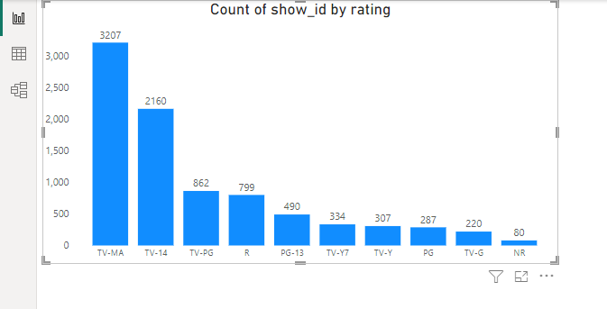

TV-MA is the most common rating for TV-shows and movies. And it shows that most movies uploaded by Netflix were adult movies. This is because the TV-MA rating is a content rating used in the united states television industry to indicate that a particular program or movies is intended for mature audiences only. TV-MA stands for ‘TV Mature Audience’.